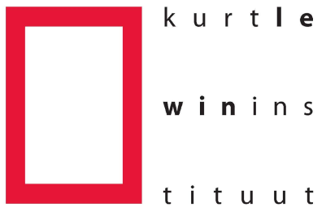
Abstract Poster presentation – KLI CONFERENCE 2020
The poster session was created to provide an opportunity for members who are not speaking in a thematic session to contribute actively to the conference program. Just like the conference themes, the poster session will cover the full breadth of social and organizational psychology, incorporating all levels of analysis. Selected posters will be invited for a Blitz talk.
KLI members who would like to present a poster can submit an abstract of max 150 words to kli.manager@uu.nl, including the names and affiliations of all authors. The deadline for submissions is March 1, 2020. In case the number of submissions exceeds the number of available poster slots, the program committee will make a selection.
Prior to the poster session, up to four presenters have the opportunity to introduce their posters with a plenary three-minute Blitz talk (total session about fifteen minutes). If you are interested to put your research in the spotlight, please indicate this on your submission. We will randomly draw four presenters from all of those who show interest.
Author name(s) and affiliation(s):
Abstract (max 150 words):

Prior to the poster session, up to four presenters have the opportunity to introduce their posters with a plenary three-minute Blitz talk. Please indicate if you would like to be considered to present:
Yes / No
Deadline for submission: March 1st, 2020.
Please email this abstract to kli.manager@uu.nl

